# Objective 1: Problems

You should attempt both problems.

## Visual dice problem

Difficulty: 🛠

Write a program that will output the number 5 on a dice like this:

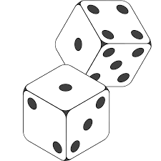**oooooooooooo**

**o o**

**o # # o**

**o # o**

**o # # o**

**o o**

**oooooooooooo**

## ASCII art problem

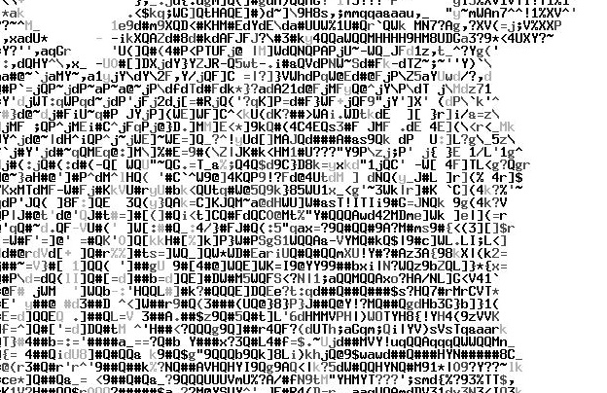Difficulty: 🛠

ASCII *(pronounced: as-key)* art is a graphic design technique of making pictures using only the 95 printable characters on a keyboard.

Write a program that outputs your name in ASCII Art.

You may find it easier to create the final output in Notepad first and then copy the lines into the programming language.

